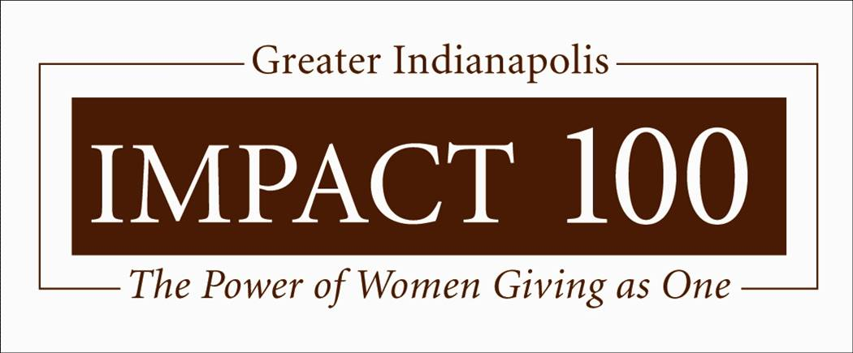

Letter of Inquiry 2017

Dear Nonprofit:

Thank you for your interest in applying for a grant from Impact 100 Greater Indianapolis.

Completing the Letter of Inquiry (LOI) form is the first step in our process. For a complete description of our grant guidelines and process, please review all sections under Impact Grants on our website at www.impact100indy.org.

The LOI is in the form of a Word document with expandable boxes. Please submit the completed form as an attachment to grants@impact100indy.org. On the subject line, indicate 2017LOI, the applicable Focus Area Committee and your NonProfit name e.g., 2017LOI_Education_OrganizationName. Please use the same naming convention for the Word file that you attach to the email. Your organization must also submit verification of its 501c (3) status as an attachment to your LOI. The deadline for submission is January 13, 2017 by 5:00 p.m. Late submissions will not be considered. We will email the named contact person with an acknowledgement of receipt of your Letter of Inquiry within one week of the closing deadline.

Please complete all questions on the attached form. In order for our volunteers to be able to judge all submissions fully and fairly, all word count limits must be respected. Applications that exceed word count limits may not be reviewed.

Impact 100 Greater Indianapolis members will review Letters of Inquiry to determine which organizations will be invited to submit Full Grant Applications. The grant contact person will be notified of that decision and given an opportunity to speak with a member of the Focus Area Committee to discuss the grant decision process.

By submitting a Letter of Inquiry, you are agreeing that you have read and understand the sample Terms of Agreement and the interim and financial report samples, which are available at www.impact100indy.org. Further, if your organization is selected to receive an Impact 100 Greater Indianapolis grant, you will be required to execute a Terms of Grant document and submit interim reports and a final report substantially similar to the samples on the website.

If you have questions regarding the form or the process, please email us at grants@impact100indy.org.

Sincerely,

Impact 100 Greater Indianapolis

Impact 100 Greater Indianapolis
2017 Letter of Inquiry

Please complete the expandable boxes. If you have any questions, please feel free to contact us at grants@impact100indy.org.

Organization Information
Please collect the following information describing your organization. You will be asked to supply each of these items in the Letter of Inquiry.

Name of organization:

Legal name (if different):

Year founded:

Employer ID Number (EIN):

Organization is designated as a 501c (3) and/or 509(a) (Yes / No):

Organization’s address

Phone:

Website:

Executive Director/CEO:

Grant proposal contact:

Contact’s phone:

Contact’s email:

Annual operating budget:

Does your organization have a CPA Audit or Financial Review for 2015? ____ Yes ____ No

Does your organization have a CPA Audit or Financial Review for 2014? ____ Yes ____ No

Which 990 will your organization submit for 2015 (check one)?

___990 ___990-EZ ___990-N ___No 990 submitted

Endowment value (if applicable):

Number of paid staff:

Number of volunteers (last year):

Percent of board members who contribute financially:

Mission statement:

Primary programs and services (250 words):

Focus Area

Please select which Focus Area best matches your application:

___ Education ___ Arts & Culture ___ Environment ___ Family ___ Health & Wellness.

Summary Information
Impact 100 grants are for $100,000. Please provide a narrative description of your proposed project or program, addressing these issues. (750 words)
- Project or program title
- Is this a current, new or expanded project/program, or a new partnership?
- 2-3 sentence summary of the proposal
- Total proposed budget for project or program
- Total dollars committed to date
- Request as a percent of total cost
- Geographic areas and populations served by project or program
- If requesting capital funds as part of project, are they for building or equipment or both?

Narrative

Please provide a narrative that addresses the following elements:

Target Population (350 words)

Describe the specific need your project or program addresses.

Describe the size and demographics of the target population. Use corroborative statistical data, such as central Indiana SAVI (Social Assets and Vulnerabilities) data or government demographic data if applicable.
- Describe who will benefit from the proposed program.

Project Goals and Outcomes (350 words)

How does your proposed project or program address the need described above?

Outline the timetable for the project. (2 year maximum)

Describe the project’s goals, proposed outcomes and methods of evaluation.
- Who are your partners and what role will they play?

Funding and Sustainability (350 words)

How will you spend Impact 100’s grant money? A detailed budget is not required at this point, but please outline principle categories of spending.

Identify the major funders already secured or committed for this proposal. List foundation, internal cash support, in-kind gifts or services and the amount of funds committed from these major sources.

Address how this project will continue when the grant money has been spent.

This Letter of Intent must have the explicit approval of both the organization’s Executive Director/CEO and the Chair of the Board of Directors. Please confirm by initialing this box:

Step 3: Online Submission

- Complete the Letter of Inquiry Form using your prepared information
- Email the completed form and 501c(3) as attached documents to grants@impact100indy.org by January 13, 2017 at 5:00 pm.
Reminder:
Email subject line: 2017LOI_Focus Area Committee_OrganizationName
Name of file: 2017LOI_Focus Area Committee_OrganizationName
- Letters of Inquiry will be acknowledged electronically.

