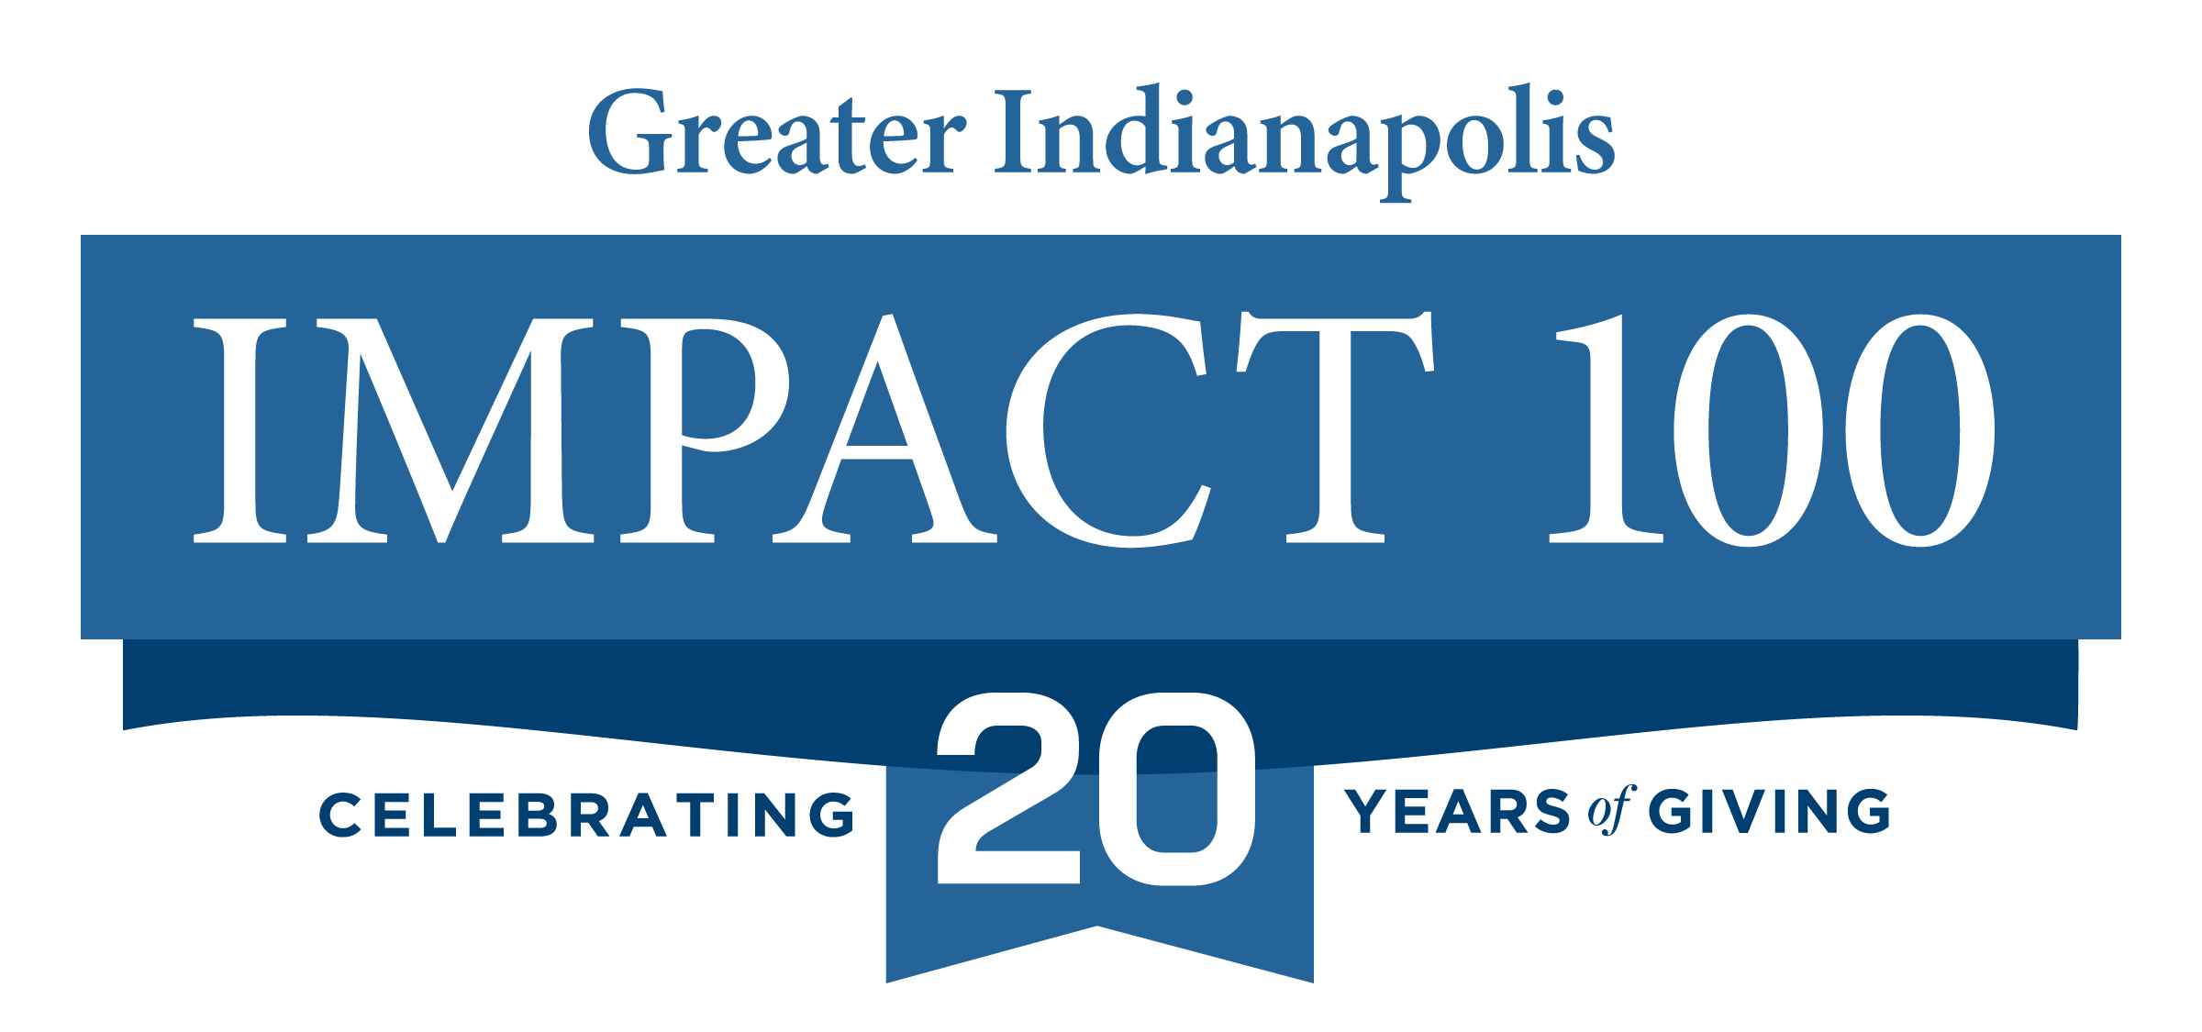

**FOR IMMEDIATE RELEASE**

May 28, 2025

**Impact 100 Greater Indianapolis names 2025 Change Maker Finalists during “Big Reveal”**

*In its 20th year of grant making, charitable women’s giving circle names five nonprofits who will vie for a $100,000 grant in June 2025!*

**INDIANAPOLIS –** [Impact 100 Greater Indianapolis](http://www.impact100indy.org), a charitable women’s giving circle, announced during their “Big Reveal” event on May 21, 2025 the five Central Indiana nonprofit organizations that will compete for a $100,000 high-impact grant on June 17, 2025.

The Impact 100 Greater Indianapolis 2025 Change Maker winner will be named during the 20th Annual Celebration event in which current members will cast their votes following a seven-minute presentation from each of the finalists. One nonprofit will be awarded the 2025 Impact 100 Change Maker $100,000 high-impact grant with the other four finalists receiving residual grants of $15,000 each. Following the celebration, the women of Impact 100 will have surpassed $3 million in grants awarded to Central Indiana nonprofit organizations during its 20-year history.

2025 Change Maker finalists in the five focus areas are:

* **Arts, Culture & Preservation**: [Big Car Collaborative](https://impact100indy.us14.list-manage.com/track/click?u=769637a33ae277cec1692a242&id=f4cdb219b4&e=cbec9ee022): The Big Table: Culinary Arts and Community Wellbeing
* **Education**: [Nine13 Sports](https://impact100indy.us14.list-manage.com/track/click?u=769637a33ae277cec1692a242&id=8951e3f123&e=cbec9ee022): Using the Bicycle as the Ultimate STEM Education Tool
* **Environment & Animal Welfare**: [Indy Humane](https://impact100indy.us14.list-manage.com/track/click?u=769637a33ae277cec1692a242&id=eaf676cf2b&e=cbec9ee022): Pet Resource Center
* **Family**: [Indiana Diaper Bank](https://impact100indy.us14.list-manage.com/track/click?u=769637a33ae277cec1692a242&id=bdb87f61ca&e=cbec9ee022): Mobile Distribution to Meet Community Needs
* **Health & Wellness**:[Coburn Place](https://impact100indy.us14.list-manage.com/track/click?u=769637a33ae277cec1692a242&id=a911040ac3&e=cbec9ee022): The SHIELD Safety Project

“In its 20th year, Impact 100 Greater Indianapolis continues its mission of making transformational gifts available to the community where we live while empowering women to get to know nonprofits on a deeper-level and determining local needs,” said Freedom Smith, president of Impact 100 Greater Indianapolis. “We are ecstatic to have these five nonprofits as Change Maker finalists and hope members of the community will join us at our 20th celebration to celebrate them and to learn how the Impact 100 giving circle works to award transformative grants to organizations with innovative ideas for solving social problems.”

To date, 22 local nonprofits have received $100,000 high-impact grants and 58 have received unrestricted, residual grants as a result of Impact 100 Greater Indianapolis’ collective giving. Previous Change Makers include: 91 Place (2024); Unconditional Indy (2023); NeuroHope of Indiana (2022); Home Repairs for Good (2021); Family Promise of Hendricks County (2020); Kennedy King Memorial Initiative (2019); Brookside Community Development Corporation and Trinity Episcopal Church (2018); **Volunteers of America of Ohio & Indiana** (2017); The IMPACT Project (a joint project between Ascent 121 and Lutheran Child and Family Services) (2016); Indianapolis Parks Foundation for Indy Urban Acres Flower Farm (2015); LifeSmart Youth (2014); Tindley Collegiate (2013); Jameson Camp, Inc. (2012); Outside the Box, Inc. (2011); Rock Steady Boxing (2010); Outreach, Inc. (2009); Herron High School and Horizon House (2008); Indy Reads and Craine House/Fairbanks (2007); and Wishard/Eskenazi (2006).

Membership in Impact 100 Greater Indianapolis is secured through an individual donation of $1,000. Shared memberships in which two to four women pool their money to share one vote are also available. Membership funds are used exclusively for the purpose of grant making, with more than 200 women collectively giving $160,000 to the 2025 grant pool.

Only current Impact 100 members are eligible to vote for the selection of the 2025 Change Makers, but the organization encourages non-members to attend the Annual Celebration when the winner of the 2025 $100,000 Change Maker grant will be announced. Tickets to attend the event can be purchased on [Eventbrite](https://www.eventbrite.com/e/20th-annual-impact-100-greater-indianapolis-awards-celebration-tickets-1332601710589?aff=oddtdtcreator).

###

***About Impact 100 Greater Indianapolis***

Founded in 2006, Impact 100 Greater Indianapolis is a 501(C)(3) charitable women’s giving circle dedicated to awarding high impact grants totaling $100,000 or more to at least one nonprofit in the greater Indianapolis community in the areas of arts, culture and preservation; education; environment and animal welfare; family; and health and wellness. The organization seeks to fund critical needs, new ventures, and innovative ways to solve social problems and to create a more civil and respectful climate in our community. Impact 100 Greater Indianapolis has a minimum of 100 members, each donating $1,000 per year to fund the grants. For more information about Impact 100 Greater Indianapolis, visit [www.impact100indy.org](http://www.impact100indy.org) or follow us on [Instagram](https://www.instagram.com/impact100indy/), [LinkedIn](https://www.linkedin.com/company/impact-100-of-greater-indianapolis/?viewAsMember=true), and [Facebook](https://www.facebook.com/impact100indy).

**Media Contact**

Kelly Asiala

[kasiala@hirons.com](mailto:kasiala@hirons.com)

260-444-8141